As I explored DPGraph, I came across a graph called Schwarz's P Surface. It looks like a 6 way pipe connector of sorts, a cube where each face transitions into an open circle:
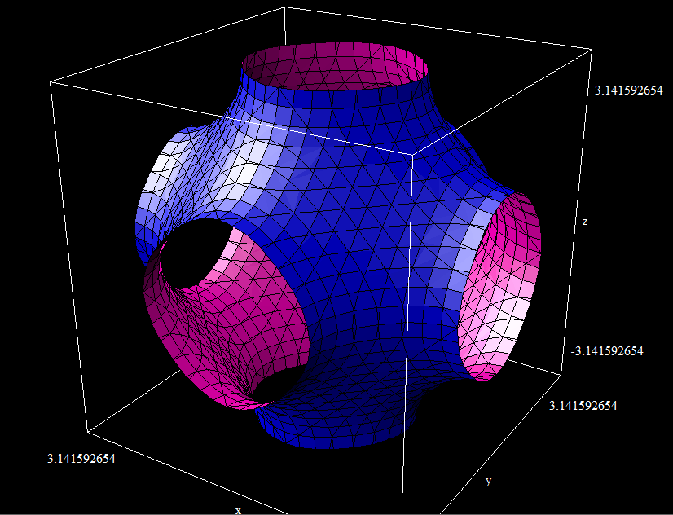
Note that each axis goes from –π to +π- this suggests it has to do with trigonometric functions, and it does. Schwarz’s P Surface is described by the equation
$$\cos\left(x\right)+\cos\left(y\right)+\cos\left(z\right)=0$$
It is what is called “triply periodic”, meaning that it repeats over all three axes. You can think of this graph in DPGraph as a “unit cell” of the surface- it will keep going in a lattice, with each open circle connecting to one of the adjacent circles. This surface was found to be a minimal surface by Hermann Amandus Schwarz, and is called the “P” surface as it is primitive- there are also “D” (Diamond) and “H” (Hexagonal) Schwarz surfaces. The simplicity of this equation is what makes it so fascinating.
A minimal surface is a surface that minimizes local surface area. There are many definitions for a minimal surface, but to put it one way a minimal surface is one that has a mean curvature of zero.
For me, what makes this specific surface of interest is its uses in crystallography and material science. Unit cells and lattices are a big part of materials science, and the Schwarz P surface is the most basic model for a triply periodic surface. In some senses, it is the foundation of modelling crystal surfaces mathematically.
After learning more about the surface, I decided to play with the parameters. For example, it appears that changing the coefficient inside the cosine terms expands or contracts the surface in that direction. Here is the graph of the equation cos(3x)+cos(z)+cos(y)=0:
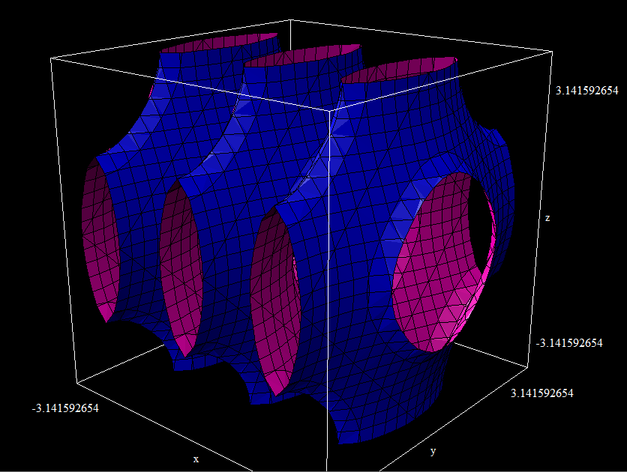
It is evident that increasing the factor in the cos(x) term makes the graph contract along the x axis-in can go through more iterations with the factor of 3. If instead we divide by 3, something interesting happens (next page):
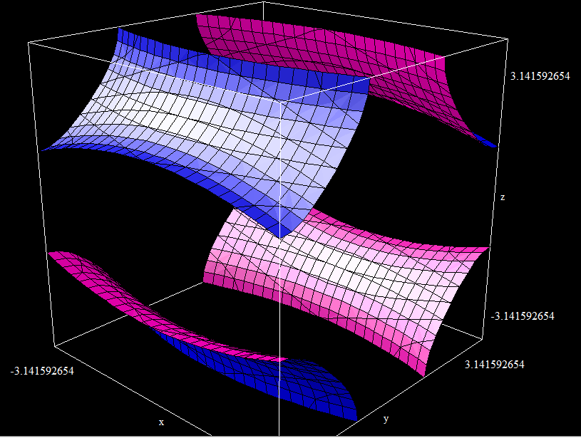
By dividing the x term in the cosine by 3, it appears that the graph is expanded along the x axis, which is to be expected. It appears disconnected because of the size of the viewing window. It is curious what would happen as this dividing number approached infinity- would the lattice be stretch immensely, until it finally became discontinuous?
Here is another view of the lattice, showing its periodicity:
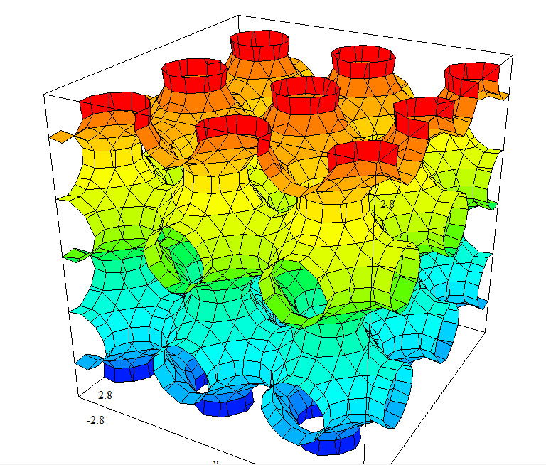
It is a very interesting, yet simple lattice work. The beginning of many interesting and more complex triply periodic surfaces!

